STA
Project Name : STA
Source Coding : vb.net
Database : Mysql
Developer Server:
IP Server :169.38.77.190
User name : root
Password : Flexi@123
Database name: sta
Live Server:
IP Server : 169.38.77.170
User Name: production
Password: B4#2q*tp27
Database Name: sta
Port no : 2728

Transaction:
Inward Entry:
Any request will come enter the Inward Entry:
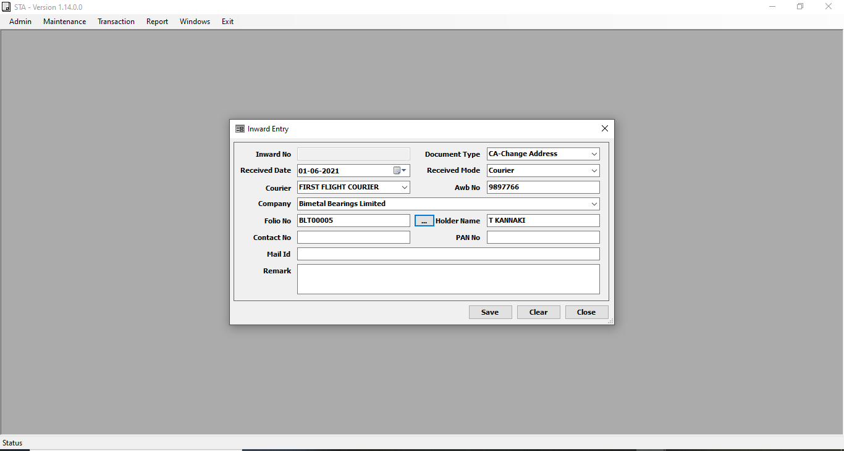

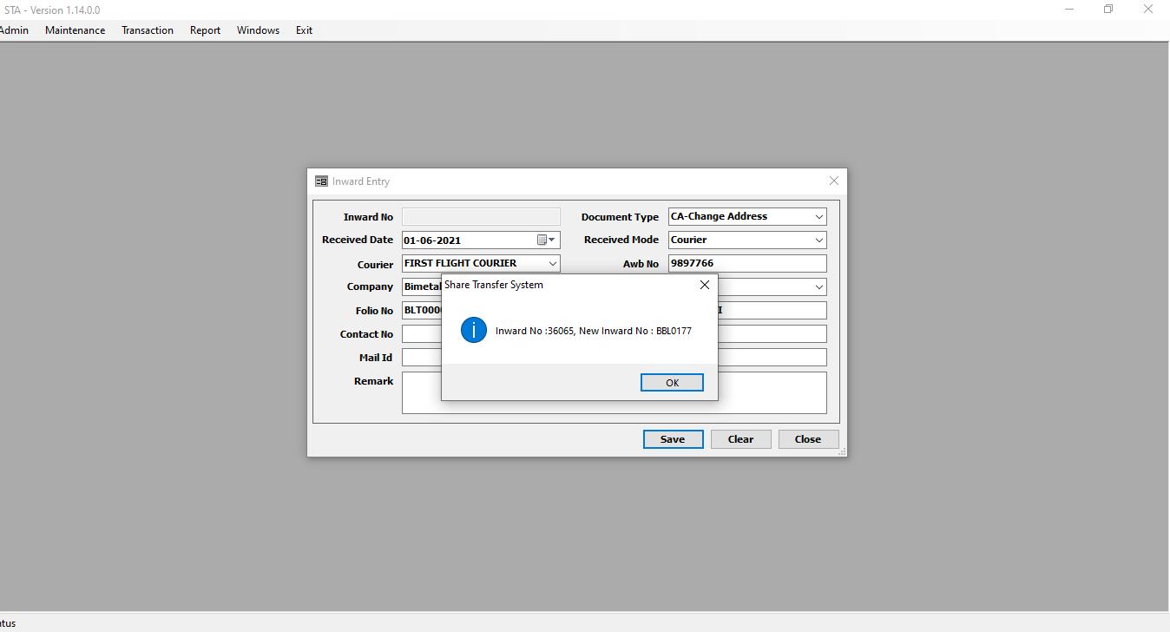
After insert the record the inward no and new inward no generate.

Next Inward Maker Screen:
The Maker Queue displayed all records
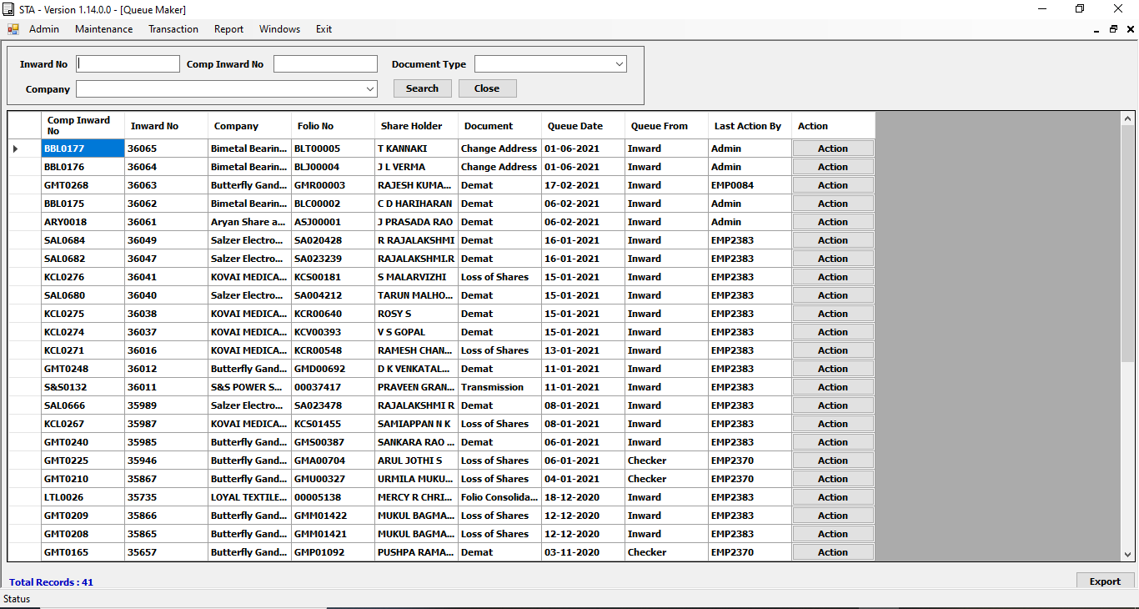
Click the action button open the Maker Entry.
The Maker Entry Screen displayed for document type against,then adding attachment file option is there.
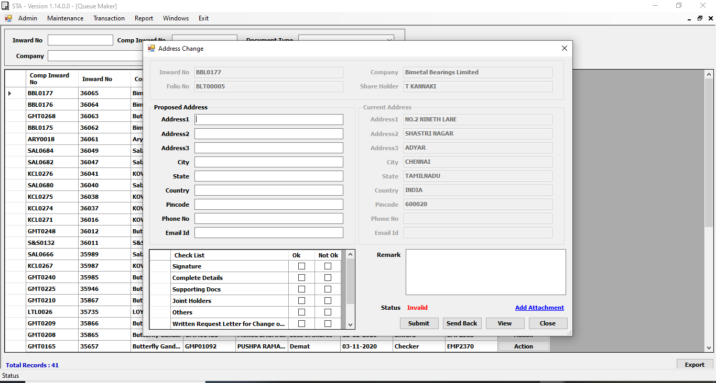
Next Checker Screen Queue:
The Checker Screen Queue Displayed the Maker Completed Data.
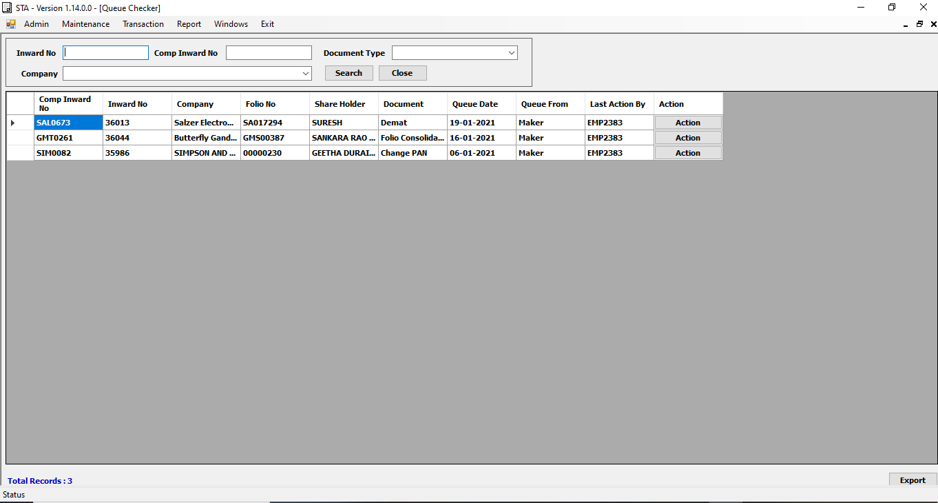
Then When will click Action Open the Checker Screen Data entry.
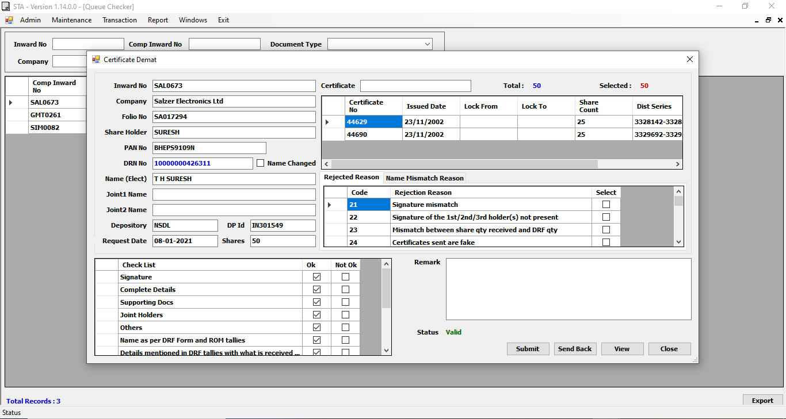

Import Option:
If any file import using this screen
Select File type ,then select the excel file after that import the file.
So basically benpost cdsl and benpost nsdl files, then history dividend file imported using this screen.
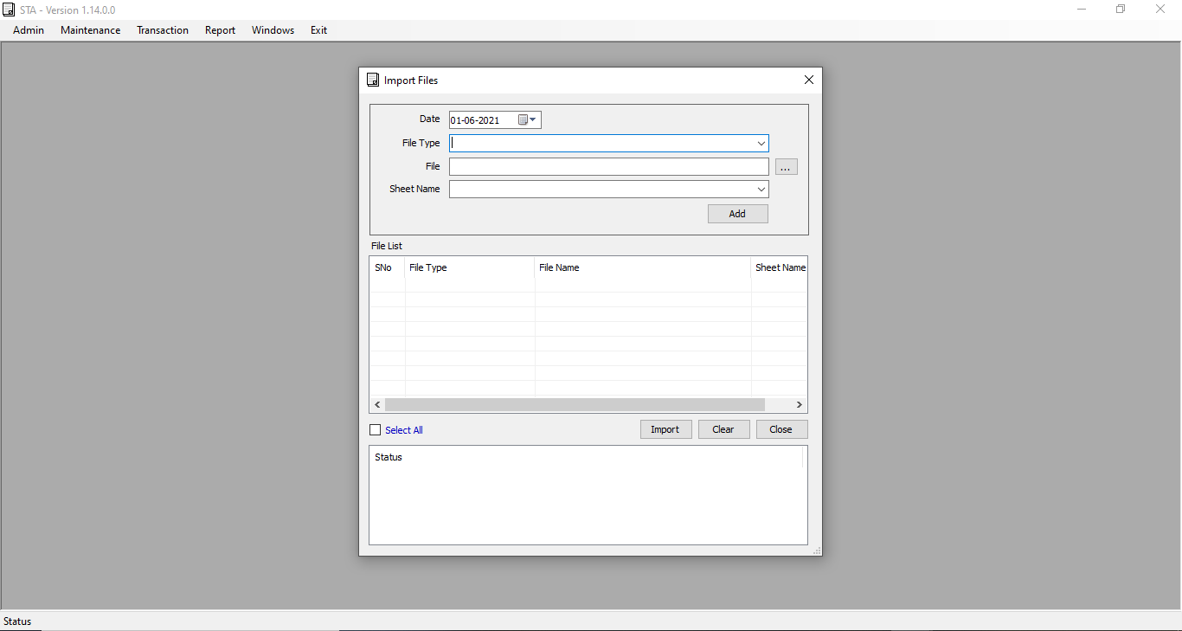

Address Label Printing Screen
This Screen using for print the address lable.
First import the Excel File after that get address label printing format in Text File.
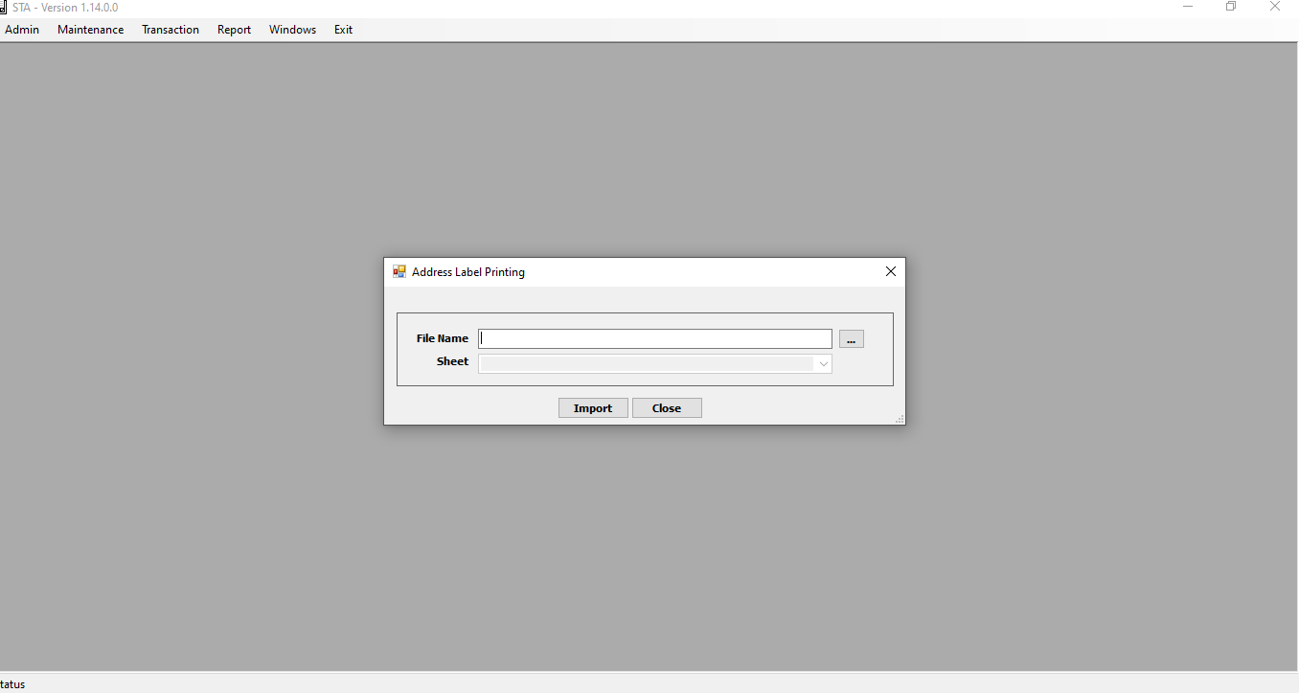
IEPF UPLOAD SCREEN
IEPF Upload Screen ,upload the excel file ,then company code and transfer type stored to separate table and excel data stored to separate table.
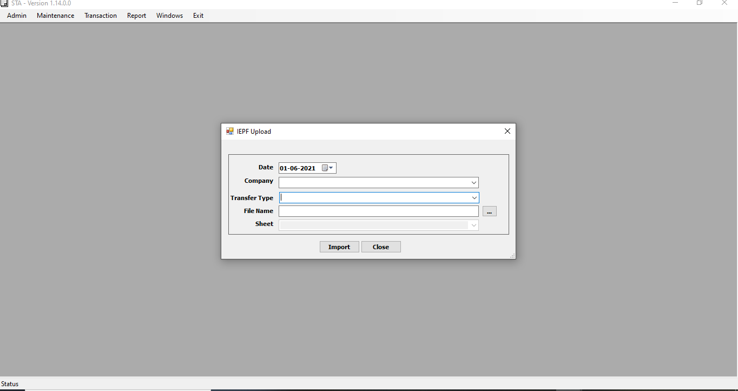

REVOKE IEPF UPLOAD
If want revoke the file, select the company and excel name, then revoke the data.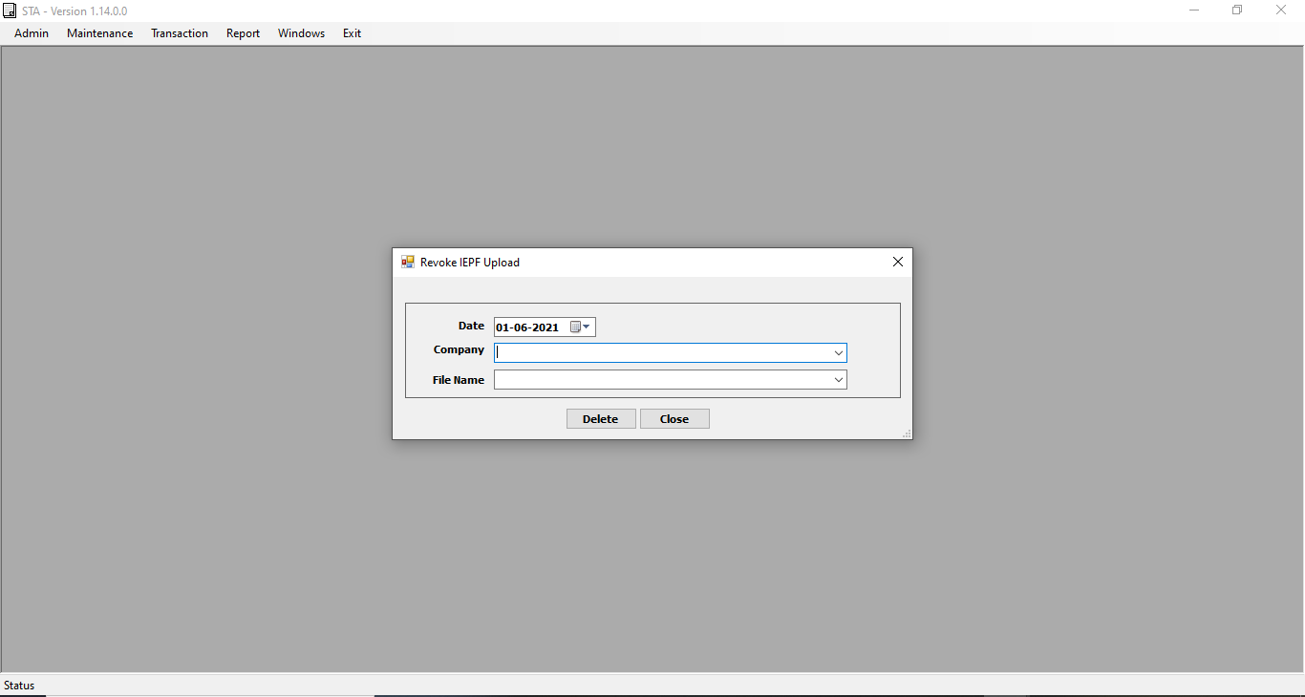
E-Voting Process
The E-Voting process Two types are there One is NSDL and CDSL
The NSDL E-Voting Screen, Enter the Batch No,Cut off date,shr id ,Even no and Excel File.
Then Excel File uploaded after that generate text file.
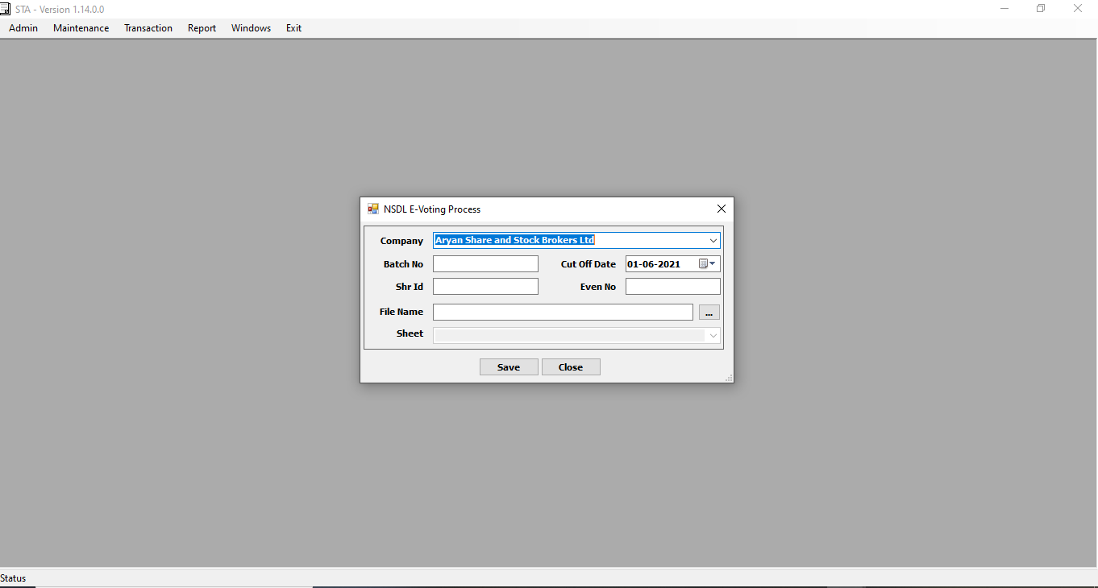

CDSL E-Voting Process
The CDSL E-Voting Process screen also enter the even no after that excel file upload.
Then generate the text file.

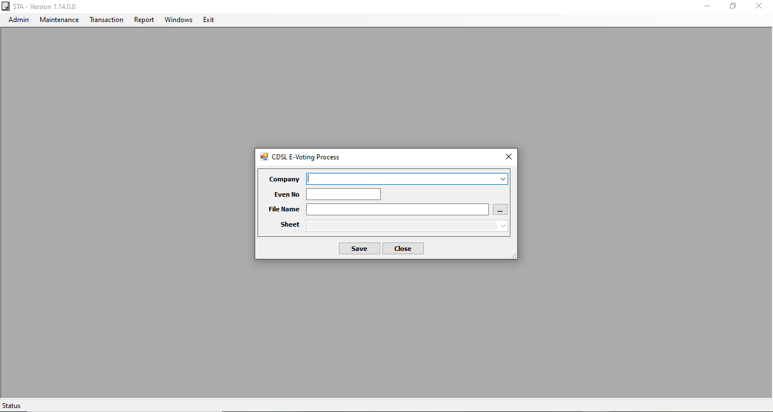

Import Tables:
sta_trn_tfolio : Folio Table stored the Physical shares.
sta_trn_tbenpost : Benpost table stored the CDSL and NSDL Share’s.
sta_trn_tdividendhistory : Dividend History storing the dividend data,this data display the EROM Dividend Screen.
sta_trn_tcert : Cert table storing the Share Certificate data’s. this table stored to certificate no and share count.
sta_trn_tcertdist : Cerificate dist table stored to dist from and to number stored.
Source Path: \\169.38.77.180\New_volume\Murali\KT\STA\STA_FinalSource

